

**LAB ASSIGNMENT**

**NAME: MUNEEB IQBAL**

**REG NO# SP22-BCS-030**

**COURSE TITLE: WEB TECHNOLOGIES**

**SUBMITTED TO: SIR M.IBRAHIM**

**DATE: 12/11/2024**

**TASK 1:**

**USING LOCAL STORAGE:**

**Index.html:**

<!doctype html>

<html lang="en">

  <head>

    <!-- Required meta tags -->

    <meta charset="utf-8">

    <meta name="viewport" content="width=device-width, initial-scale=1">

    <!-- Bootstrap CSS -->

    <link href="https://cdn.jsdelivr.net/npm/bootstrap@5.0.2/dist/css/bootstrap.min.css" rel="stylesheet" integrity="sha384-EVSTQN3/azprG1Anm3QDgpJLIm9Nao0Yz1ztcQTwFspd3yD65VohhpuuCOmLASjC" crossorigin="anonymous">

    <!--Bootstrap 5 icons CDN-->

    <link rel="stylesheet" href="https://cdn.jsdelivr.net/npm/bootstrap-icons@1.10.5/font/bootstrap-icons.css">

    <title>CRUD Operations</title>

    <link rel="stylesheet" href="style.css">

  </head>

  <body>

    <section class="p-3">

        <div class="row">

            <div class="col-12">

                <button class="btn btn-primary newUser" data-bs-toggle="modal" data-bs-target="#userForm">New User <i class="bi bi-people"></i></button>

            </div>

        </div>

        <div class="row">

            <div class="col-12">

                <table class="table table-striped table-hover mt-3 text-center table-bordered">

                    <thead>

                        <tr>

                            <th>S.No</th>

                            <th>Picture</th>

                            <th>Name</th>

                            <th>Age</th>

                            <th>City</th>

                            <th>Email</th>

                            <th>Phone</th>

                            <th>Post</th>

                            <th>Start Date</th>

                            <th>Action</th>

                        </tr>

                    </thead>

                    <tbody id="data"></tbody>

                </table>

            </div>

        </div>

    </section>

    <!--Modal Form-->

    <div class="modal fade" id="userForm">

        <div class="modal-dialog modal-dialog-centered modal-lg">

            <div class="modal-content">

                <div class="modal-header">

                    <h4 class="modal-title">Fill the Form</h4>

                    <button type="button" class="btn-close" data-bs-dismiss="modal" aria-label="Close"></button>

                </div>

                <div class="modal-body">

                    <form action="#" id="myForm">

                        <div class="card imgholder">

                            <label for="imgInput" class="upload">

                                <input type="file" name="" id="imgInput">

                                <i class="bi bi-plus-circle-dotted"></i>

                            </label>

                            <img src="./image/Profile Icon.webp" alt="" width="200" height="200" class="img">

                        </div>

                        <div class="inputField">

                            <div>

                                <label for="name">Name:</label>

                                <input type="text" name="" id="name" required>

                            </div>

                            <div>

                                <label for="age">Age:</label>

                                <input type="number" name="" id="age" required>

                            </div>

                            <div>

                                <label for="city">City:</label>

                                <input type="text" name="" id="city" required>

                            </div>

                            <div>

                                <label for="email">E-mail:</label>

                                <input type="email" name="" id="email" required>

                            </div>

                            <div>

                                <label for="phone">Number:</label>

                                <input type="text" name="" id="phone" minlength="11" maxlength="11" required>

                            </div>

                            <div>

                                <label for="post">Post:</label>

                                <input type="text" name="" id="post" required>

                            </div>

                            <div>

                                <label for="sDate">Start Date:</label>

                                <input type="date" name="" id="sDate" required>

                            </div>

                        </div>

                    </form>

                </div>

                <div class="modal-footer">

                    <button type="button" class="btn btn-secondary" data-bs-dismiss="modal">Close</button>

                    <button type="submit" form="myForm" class="btn btn-primary submit">Submit</button>

                </div>

            </div>

        </div>

    </div>

    <!--Read Data Modal-->

    <div class="modal fade" id="readData">

        <div class="modal-dialog modal-dialog-centered modal-lg">

            <div class="modal-content">

                <div class="modal-header">

                    <h4 class="modal-title">Profile</h4>

                    <button type="button" class="btn-close" data-bs-dismiss="modal" aria-label="Close"></button>

                </div>

                <div class="modal-body">

                    <form action="#" id="myForm">

                        <div class="card imgholder">

                            <img src="./image/Profile Icon.webp" alt="" width="200" height="200" class="showImg">

                        </div>

                        <div class="inputField">

                            <div>

                                <label for="name">Name:</label>

                                <input type="text" name="" id="showName" disabled>

                            </div>

                            <div>

                                <label for="age">Age:</label>

                                <input type="number" name="" id="showAge" disabled>

                            </div>

                            <div>

                                <label for="city">City:</label>

                                <input type="text" name="" id="showCity" disabled>

                            </div>

                            <div>

                                <label for="email">E-mail:</label>

                                <input type="email" name="" id="showEmail" disabled>

                            </div>

                            <div>

                                <label for="phone">Number:</label>

                                <input type="text" name="" id="showPhone" minlength="11" maxlength="11" disabled>

                            </div>

                            <div>

                                <label for="post">Post:</label>

                                <input type="text" name="" id="showPost" disabled>

                            </div>

                            <div>

                                <label for="sDate">Start Date:</label>

                                <input type="date" name="" id="showsDate" disabled>

                            </div>

                        </div>

                    </form>

                </div>

            </div>

        </div>

    </div>

    <!-- Option 1: Bootstrap Bundle with Popper -->

    <script src="https://cdn.jsdelivr.net/npm/bootstrap@5.0.2/dist/js/bootstrap.bundle.min.js" integrity="sha384-MrcW6ZMFYlzcLA8Nl+NtUVF0sA7MsXsP1UyJoMp4YLEuNSfAP+JcXn/tWtIaxVXM" crossorigin="anonymous"></script>

    <script src="script.js"></script>

  </body>

</html>

**Style.css:**

table tr td{

    vertical-align: middle;

}

td button{

    margin: 5px;

}

td button i{

    font-size: 20px;

}

.modal-header{

    background: #0d6efd;

    color: #fff;

    margin: 0;

    padding: 6px;

}

.modal-body form {

    display: flex;

    justify-content: space-between;

    align-items: flex-start;

    padding: 0;

}

.modal-body form .imgholder{

    width: 200px;

    height: 200px;

    position: relative;

    border-radius: 20px;

    overflow: hidden;

}

.imgholder .upload{

    position: absolute;

    bottom: 0;

    left: 10;

    width: 100%;

    height: 100px;

    background: rgba(0,0,0,0.3);

    display: none;

    justify-content: center;

    align-items: center;

    cursor: pointer;

}

.upload i{

    color: #fff;

    font-size: 28px;

}

.imgholder:hover .upload{

    display: flex;

}

.imgholder .upload input{

    display: none;

}

.modal-body form .inputField{

    flex-basis: 68%;

    border-left: 5px groove blue;

    padding-left: 20px;

}

form .inputField > div{

    width: 100%;

    display: flex;

    justify-content: space-between;

    align-items: center;

    margin-bottom: 6px;

}

form .inputField > div label{

    font-size: 16px;

    font-weight: 500;

}

#userForm form .inputField > div label::after{

    content: "*";

    color: red;

}

form .inputField > div input{

    width: 75%;

    padding: 10px;

    border: none;

    outline: none;

    background: transparent;

    border-bottom: 2px solid blue;

}

.modal-footer .submit{

    font-size: 18px;

}

#readData form .inputField > div input{

    color: #000;

    font-size: 18px;

}

**Script.js:**

var form = document.getElementById("myForm"),

    imgInput = document.querySelector(".img"),

    file = document.getElementById("imgInput"),

    userName = document.getElementById("name"),

    age = document.getElementById("age"),

    city = document.getElementById("city"),

    email = document.getElementById("email"),

    phone = document.getElementById("phone"),

    post = document.getElementById("post"),

    sDate = document.getElementById("sDate"),

    submitBtn = document.querySelector(".submit"),

    userInfo = document.getElementById("data"),

    modal = document.getElementById("userForm"),

    modalTitle = document.querySelector("#userForm .modal-title"),

    newUserBtn = document.querySelector(".newUser")

let getData = localStorage.getItem('userProfile') ? JSON.parse(localStorage.getItem('userProfile')) : []

let isEdit = false, editId

showInfo()

newUserBtn.addEventListener('click', ()=> {

    submitBtn.innerText = 'Submit',

    modalTitle.innerText = "Fill the Form"

    isEdit = false

    imgInput.src = "./image/Profile Icon.webp"

    form.reset()

})

file.onchange = function(){

    if(file.files[0].size < 1000000){  // 1MB = 1000000

        var fileReader = new FileReader();

        fileReader.onload = function(e){

            imgUrl = e.target.result

            imgInput.src = imgUrl

        }

        fileReader.readAsDataURL(file.files[0])

    }

    else{

        alert("This file is too large!")

    }

}

function showInfo(){

    document.querySelectorAll('.employeeDetails').forEach(info => info.remove())

    getData.forEach((element, index) => {

        let createElement = `<tr class="employeeDetails">

            <td>${index+1}</td>

            <td><img src="${element.picture}" alt="" width="50" height="50"></td>

            <td>${element.employeeName}</td>

            <td>${element.employeeAge}</td>

            <td>${element.employeeCity}</td>

            <td>${element.employeeEmail}</td>

            <td>${element.employeePhone}</td>

            <td>${element.employeePost}</td>

            <td>${element.startDate}</td>

            <td>

                <button class="btn btn-success" onclick="readInfo('${element.picture}', '${element.employeeName}', '${element.employeeAge}', '${element.employeeCity}', '${element.employeeEmail}', '${element.employeePhone}', '${element.employeePost}', '${element.startDate}')" data-bs-toggle="modal" data-bs-target="#readData"><i class="bi bi-eye"></i></button>

                <button class="btn btn-primary" onclick="editInfo(${index}, '${element.picture}', '${element.employeeName}', '${element.employeeAge}', '${element.employeeCity}', '${element.employeeEmail}', '${element.employeePhone}', '${element.employeePost}', '${element.startDate}')" data-bs-toggle="modal" data-bs-target="#userForm"><i class="bi bi-pencil-square"></i></button>

                <button class="btn btn-danger" onclick="deleteInfo(${index})"><i class="bi bi-trash"></i></button>

            </td>

        </tr>`

        userInfo.innerHTML += createElement

    })

}

showInfo()

function readInfo(pic, name, age, city, email, phone, post, sDate){

    document.querySelector('.showImg').src = pic,

    document.querySelector('#showName').value = name,

    document.querySelector("#showAge").value = age,

    document.querySelector("#showCity").value = city,

    document.querySelector("#showEmail").value = email,

    document.querySelector("#showPhone").value = phone,

    document.querySelector("#showPost").value = post,

    document.querySelector("#showsDate").value = sDate

}

function editInfo(index, pic, name, Age, City, Email, Phone, Post, Sdate){

    isEdit = true

    editId = index

    imgInput.src = pic

    userName.value = name

    age.value = Age

    city.value =City

    email.value = Email,

    phone.value = Phone,

    post.value = Post,

    sDate.value = Sdate

    submitBtn.innerText = "Update"

    modalTitle.innerText = "Update The Form"

}

function deleteInfo(index){

    if(confirm("Are you sure want to delete?")){

        getData.splice(index, 1)

        localStorage.setItem("userProfile", JSON.stringify(getData))

        showInfo()

    }

}

form.addEventListener('submit', (e)=> {

    e.preventDefault()

    const information = {

        picture: imgInput.src == undefined ? "./image/Profile Icon.webp" : imgInput.src,

        employeeName: userName.value,

        employeeAge: age.value,

        employeeCity: city.value,

        employeeEmail: email.value,

        employeePhone: phone.value,

        employeePost: post.value,

        startDate: sDate.value

    }

    if(!isEdit){

        getData.push(information)

    }

    else{

        isEdit = false

        getData[editId] = information

    }

    localStorage.setItem('userProfile', JSON.stringify(getData))

    submitBtn.innerText = "Submit"

    modalTitle.innerHTML = "Fill The Form"

    showInfo()

    form.reset()

    imgInput.src = "./image/Profile Icon.webp"

    // modal.style.display = "none"

    // document.querySelector(".modal-backdrop").remove()

})

**WEBPAGE SCREENSHOTS:**

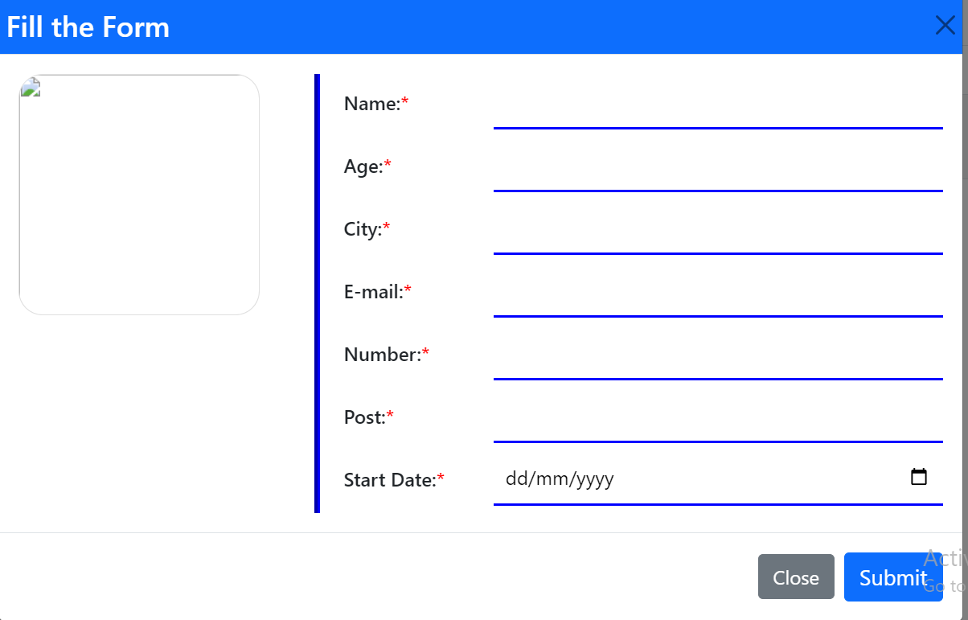

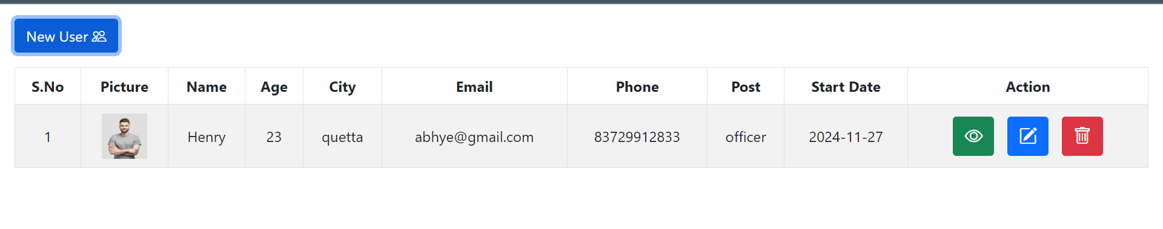

**TASK 2:**

**USING PHP AND MYSQL**

**INDEX.PHP:**

<!DOCTYPE html>

<html lang="en">

<head>

    <meta charset="UTF-8">

    <meta name="viewport" content="width=device-width, initial-scale=1.0">

    <title>CRUD Application</title>

    <link rel="stylesheet" href="https://cdnjs.cloudflare.com/ajax/libs/bootstrap/5.1.3/css/bootstrap.min.css">

</head>

<body>

    <div class="container my-5">

        <h2 class="text-center">PHP & MySQL CRUD Application</h2>

        <!-- Form for adding/updating users -->

        <form id="crudForm" class="my-4">

            <input type="hidden" id="index">

            <div class="mb-3">

                <label for="name" class="form-label">Name</label>

                <input type="text" class="form-control" id="name" required>

            </div>

            <div class="mb-3">

                <label for="email" class="form-label">Email</label>

                <input type="email" class="form-control" id="email" required>

            </div>

            <div class="mb-3">

                <label for="phone" class="form-label">Phone</label>

                <input type="text" class="form-control" id="phone" required>

            </div>

            <div class="mb-3">

                <label for="address" class="form-label">Address</label>

                <input type="text" class="form-control" id="address" required>

            </div>

            <button type="submit" class="btn btn-primary">Save</button>

        </form>

        <!-- Container for displaying users -->

        <div class="row row-cols-1 row-cols-md-3 g-4" id="dataList">

            <!-- User data will be inserted here via JavaScript -->

        </div>

    </div>

    <!-- Include JavaScript files -->

    <script src="https://cdnjs.cloudflare.com/ajax/libs/jquery/3.6.0/jquery.min.js"></script>

    <script src="script.js"></script>

</body>

</html>

**DELETE_USER.PHP:**

<?php

    $dbname = "crud-global";

    include '../include.php';

    $id = $_POST['id'];

    // Delete the user from the database

    $sql = "DELETE FROM users WHERE ID = $id"; // Ensure the correct column name

    if ($conn->query($sql) === TRUE) {

        echo "Record deleted successfully";

    } else {

        echo "Error: " . $conn->error;

    }

    $conn->close();

?>

**FETCH.PHP:**

<?php

    $dbname = "crud-global";

    include '../include.php';

    $sql = "SELECT ID, Name, Email, Phone, Address FROM users"; // Ensure the exact case of column names

    $result = $conn->query($sql);

    // Check if the query returned any rows

    if ($result->num_rows > 0) {

        // Loop through the users and output them as HTML

        while ($row = $result->fetch_assoc()) {

            echo '<div class="col mb-4">';

            echo '    <div class="card">';

            echo '        <div class="card-body">';

            echo '            <h5 class="card-title">' . $row['Name'] . '</h5>'; // Correct case

            echo '            <p class="card-text">Email: ' . $row['Email'] . '</p>';

            echo '            <p class="card-text">Phone: ' . $row['Phone'] . '</p>';

            echo '            <p class="card-text">Address: ' . $row['Address'] . '</p>';

            echo '            <button class="btn btn-warning edit-btn" data-id="' . $row['ID'] . '">Edit</button>';

            echo '            <button class="btn btn-danger delete-btn" data-id="' . $row['ID'] . '">Delete</button>';

            echo '        </div>';

            echo '    </div>';

            echo '</div>';

        }

    } else {

        echo 'No users found.';

    }

    $conn->close();

?>

**INSERT.PHP:**

<?php

    $dbname = "crud-global";

    include '../include.php';

    $name = $_POST['name'];

    $email = $_POST['email'];

    $phone = $_POST['phone'];

    $address = $_POST['address'];

    // Insert data into the database

    $sql = "INSERT INTO users (Name, Email, Phone, Address) VALUES ('$name', '$email', '$phone', '$address')";

    if ($conn->query($sql) === TRUE) {

        echo "Record added successfully";

    } else {

        echo "Error: " . $conn->error;

    }

    $conn->close();

?>

**SCRIPT.JS:**

$(document).ready(function() {

    // Display data when the page loads

    displayData();

    // Handle form submission

    $("#crudForm").on("submit", function(e) {

        e.preventDefault();

        const name = $("#name").val();

        const email = $("#email").val();

        const phone = $("#phone").val();

        const address = $("#address").val();

        const index = $("#index").val();

        // Send data to PHP script via AJAX

        $.ajax({

            url: 'insert.php', // Your PHP script to insert data

            type: 'POST',

            data: {

                name: name,

                email: email,

                phone: phone,

                address: address,

                index: index

            },

            success: function(response) {

                // After success, clear the form and fetch updated data

                console.log(response);

                displayData();

                $("#crudForm")[0].reset(); // Reset form after submission

            },

            error: function(xhr, status, error) {

                alert('Error: ' + error);

            }

        });

    });

    // Display users

    function displayData() {

        $.ajax({

            url: 'fetch.php', // Your PHP script to fetch user data

            type: 'GET',

            success: function(response) {

                $("#dataList").html(response); // Insert the returned user data into the page

            },

            error: function(xhr, status, error) {

                alert('Error: ' + error);

            }

        });

    }

    // Handle delete user

    $(document).on("click", ".delete-btn", function() {

        const userId = $(this).data("id");

        $.ajax({

            url: 'delete_user.php', // Your PHP script to delete user

            type: 'POST',

            data: { id: userId },

            success: function(response) {

                console.log(response);

                displayData();

            },

            error: function(xhr, status, error) {

                alert('Error: ' + error);

            }

        });

    });

});

**UPDATE_USER.PHP:**

<?php

    $dbname = "crud-global";

    include '../include.php';

    // Get the form data

    $id = $_POST['id'];

    $name = $_POST['name'];

    $email = $_POST['email'];

    $phone = $_POST['phone'];

    $address = $_POST['address'];

    // Update the user data in the database

    $sql = "UPDATE users SET Name = '$name', Email = '$email', Phone = '$phone', Address = '$address' WHERE ID = $id";

    if ($conn->query($sql) === TRUE) {

        echo "Record updated successfully";

    } else {

        echo "Error: " . $conn->error;

    }

    $conn->close();

?>

**INCLUDE.PHP:**

<?php

    ini_set('display_errors', 1);

    error_reporting(E_ALL);

    $servername = "localhost";

    $username = "root";

    $password = "";

    $port = 3307;

    $conn = mysqli_connect($servername, $username, $password, $dbname, $port);

?>

**WEBPAGE SCREENSHOTS:**

